|  |  |  |  |
| --- | --- | --- | --- |
| Project: | | | Manufacturer.: |
| Region: | | | Model No.: |
| Service: | | | Number of Units: |
| Equip. Tag Number(s)*: | | | Rev/Date/By: // |
| **GENERAL REQUIREMENTS** | | | |
| Equipment Capacity: kg (___tons) | Factory Testing: | | Power Supply: |
| Method of Control: | Required Not Required | | Voltage |
| Location of Control: | Field Testing: Not required | | Phase |
| Equipment Location: | Required, functional and | | Frequency |
| Indoors Outdoors | performance | |  |
| **HOIST** | | **TROLLEY** | |
| Type: | | Type: | |
| Electric, Wire Rope Hand Operated, Chain | | Top Running Underhung | |
| Service Class (ANSI): | | Service Class (ANSI): | |
| H1 (standby) H2 (light) H3 (standard) | | A1 (standby) A2 (infrequent) B (light) | |
| H4 (heavy) H5 (severe) | | C (moderate) D (heavy) | |
| Speed cm per minute (fpm):     to | | Speed cm per minute (fpm):     to | |
| Constant Speed Two Speed Variable Speed | | Constant Speed Variable Speed Hand Operated | |
| Motor kW (hp): | | Motor kW (hp): | |
| Hook: See Hoist/Monorail Dimension Sheet | | Electric Conductors: | |
| Hook Manufacturer: | | Bus Bar Festoon | |
|  | | Cable Reel | |
| **SPECIAL REQUIREMENTS** | | | |
| Accessories: | Remote Controls:** | | Special Electrical Requirements: |
| Central Lubrication System | Infrared, line-of-sight | |  |
| OHSA operating and safety | Frequency modulated (FM) | |  |
| devices | Manufacturer: | |  |
|  | Extended Grease Fittings | |  |
| See Hoist/Monorail Dimension Sheet for clearances, lift distances, and details. | | | |

*Equipment Tag Number shall conform to the Region’s Tagging Standard. Refer to Section 21 – Development and Maintenance of Asset Inventory and Tagging.  
*[DESIGN NOTE: Consultant to modify to chosen type of crane remote control above in the “Special Requirements” section (radio or pendant hard-wired)]*

Project:

Region:

Equipment Tag Number(s):

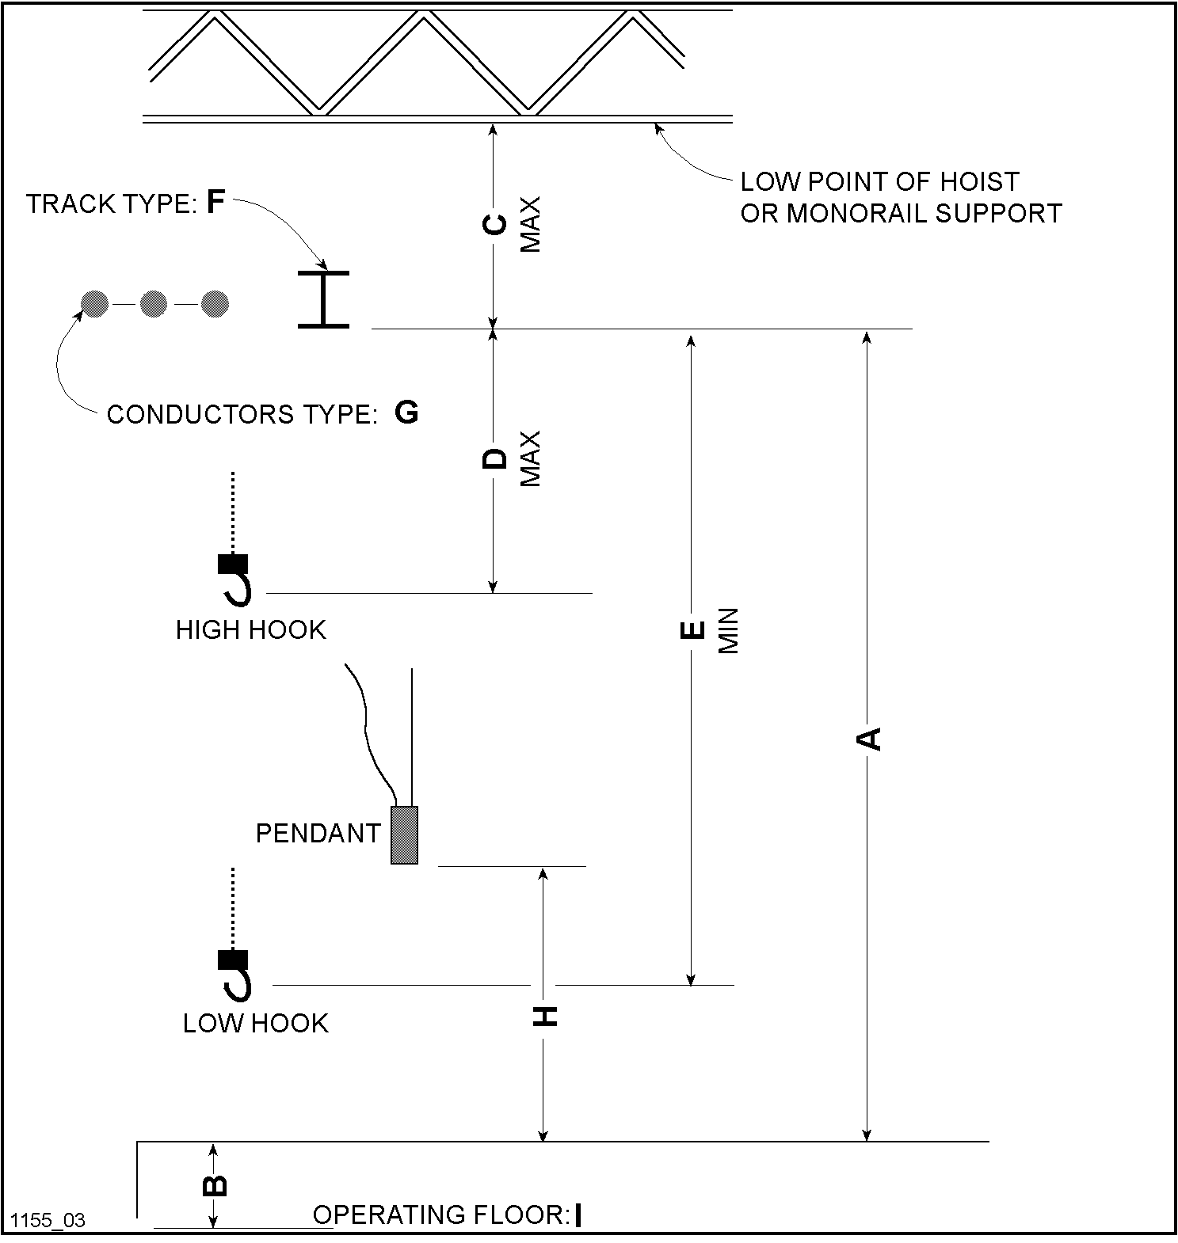

|  |  |  |
| --- | --- | --- |
| A: | D: | G: |
| B: | E: | H: |
| C: | F: | I: |